Quiz: Searching for and Selecting Resources in the Library
Clifford and the big parade
Call #: E BRI Bridwell, Norman.
Series: Clifford the big red dog
Published 1998
Reading Level: 2.7 Interest Level: K-3
Accelerated Reader® Level: 2.4 / 0.5 pts.
Lexile: 480

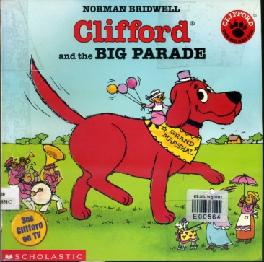

1. In which section of the library can you find this book? (1b)
a) reference
b) everybody
c) biography
d) nonfiction

Thoroughbred horses
Call #: 636.1 GAM Gammie, Janet L.
Series: Horses
Published 1996
Reading Level: 4.8 Interest Level: K-3
Accelerated Reader® Level: 4.0 / 0.5 pts.

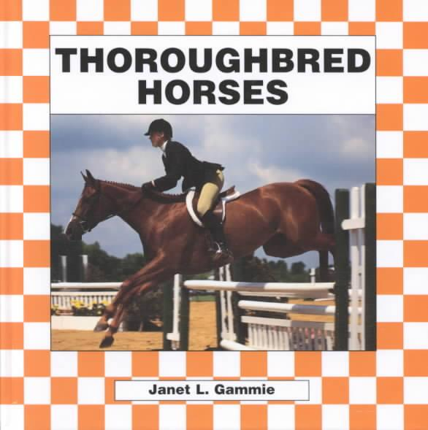

2. In which section of the library can you find this book? (1b)
a) nonfiction
b) biography
c) everybody
d) reference

3. Name two different ways to conduct a catalog search. (2a)

a)._______________________________ b.) _________________________________

4. Using the examples below, compare the books in the “everybody” section to the books in the “fiction” section. (3a)

“Everybody” (Inside the book)
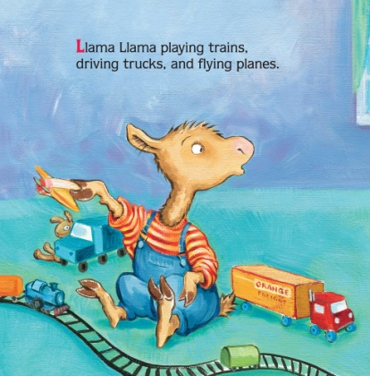
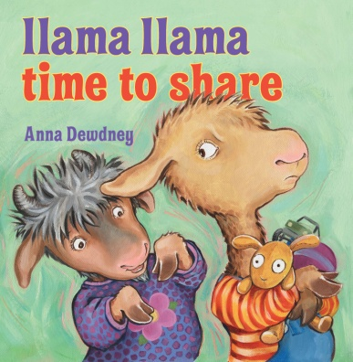

http://www.amazon.com/Llama-Time-Share-Anna-Dewdney/dp/0670012335/ref=sr_1_1?s=books&ie=UTF8&qid=1373845266&sr=1-1&keywords=llama+llama+time+to+share+by+anna+dewdney
“Fiction”
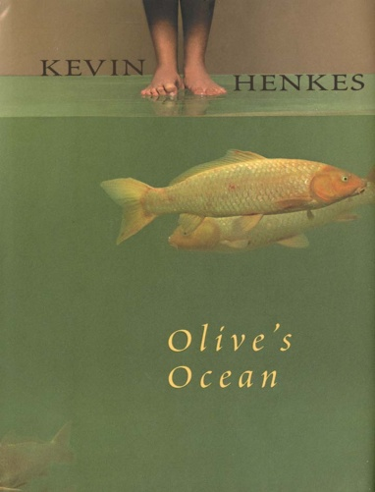

(Inside the book)

http://www.amazon.com/Olives-Ocean-Kevin-Henkes/dp/B004IH0MR2/ref=sr_1_6?ie=UTF8&qid=1373845208&sr=8-6&keywords=olive%27s+ocean+by+kevin+henkes
______________________________________________________________________________

______________________________________________________________________________

______________________________________________________________________________

______________________________________________________________________________

______________________________________________________________________________
5. How are the books organized in the nonfiction section?
Pick all that apply. (3b)
a) call numbers
b) first 3 letters of title
c) Dewey Decimal System
d) first 3 letters of author’s last name

6. How are the books organized in the fiction section?
Pick all that apply. (3b)
a) first 3 letters of author’s last name
b) Dewey Decimal System
c) first 3 letters of title
d) call numbers

7. How are the books organized in the everybody section?
Pick all that apply. (3b)
a) Dewey Decimal System
b) first 3 letters of author’s last name
c) call letter E
d) first 3 letters of title

8. How are the books organized in the reference section?
Pick all that apply. (3b)
a) first 3 letters of title
b) call letters REF or R
c) first 3 letters of author’s last name
d) Dewey Decimal System

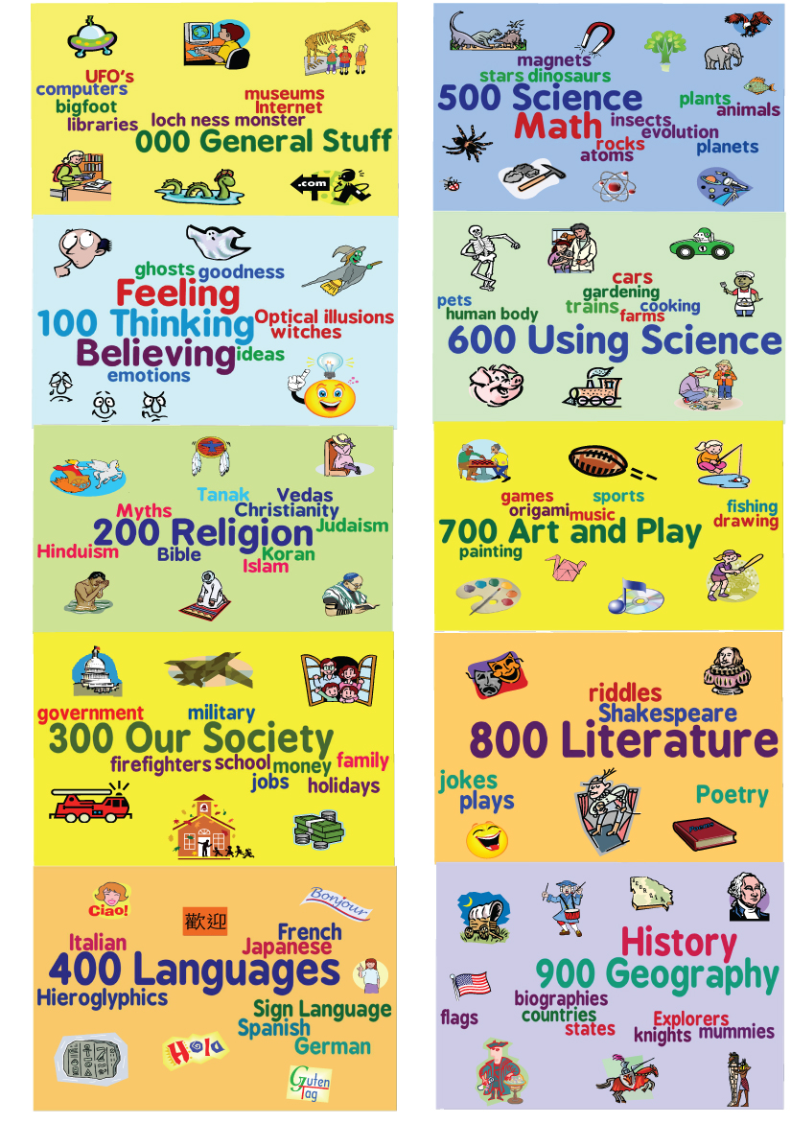
Use the Dewey Poster below to answer the following questions.
http://3.bp.blogspot.com/-xu5fztBeC4w/UIF1xXdEu9I/AAAAAAAAAqc/Ynl7SDY63CM/s1600/Dewey-wordle-poster.jpg
Match the book to the correct call number. (1b, 3b)

9. A Pocketful of Poems by Nikki Grimes * B LIN
10. The Milky Way by Steve Kortenkamp * 782 ASC
11. Barnyard Lullaby by Frank Asch * 523 KOR
12. Abraham Lincoln * 811 GRI
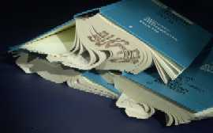
13. This is the correct way to keep a book. (4a)

True False

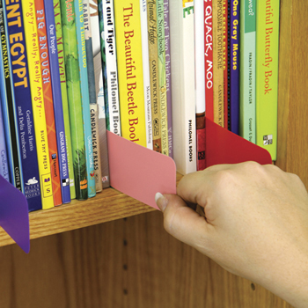
14. This is the correct way to use a shelf place marker. (4a)

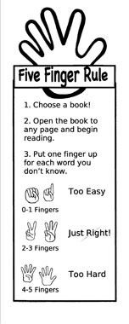
True False

15. How many words is “too hard” when selecting a just right book?
a. 0-1
b. 2-3
c. 4-5
d. none of the above

16. A book is damaged if it is… (4c)
a. colored/written in
b. has torn pages
c. has food or liquid stains
d. all of the above

______________________________________________________________________________

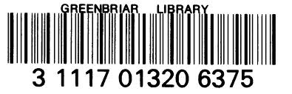

17. Where are the library barcodes located?
Select all that apply. (4d)
a. front cover of book
b. back cover of book
c. front of library card
d. back of library card

